KBE assignment 2015/2016 – Piotr Druzdzel

CATIA screenshots:

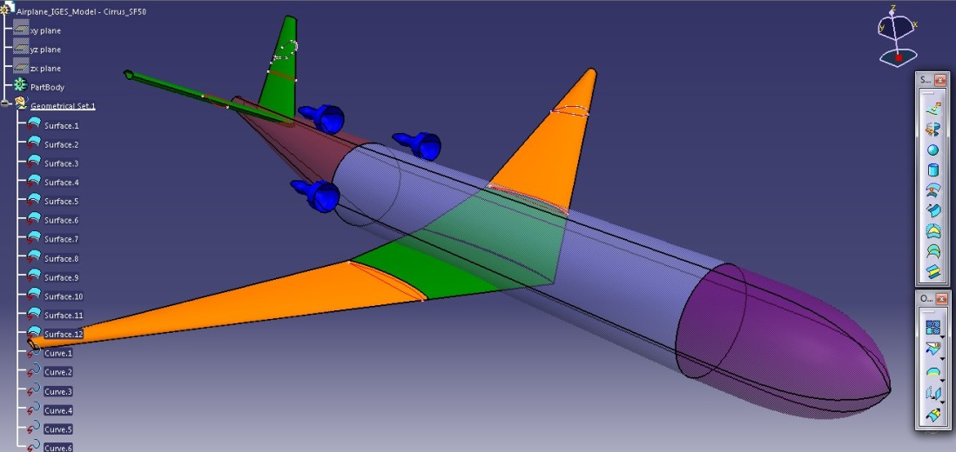

Fig. 1. Cirrus SF50

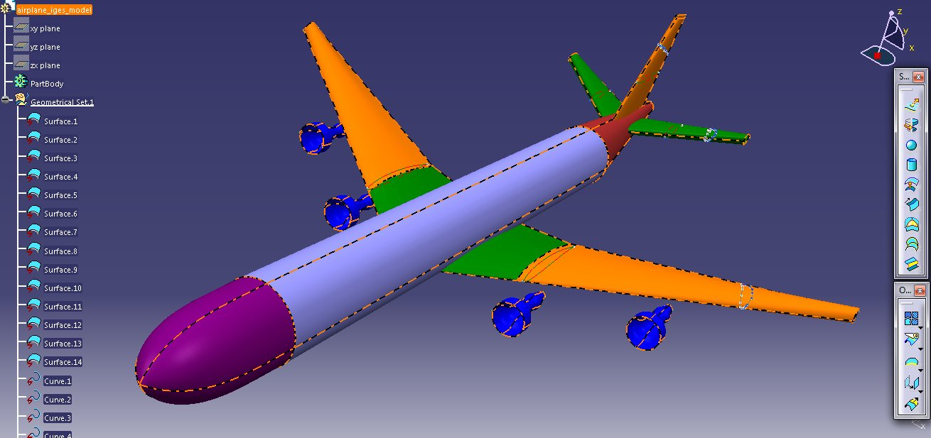

Fig. 2. Boeing 747

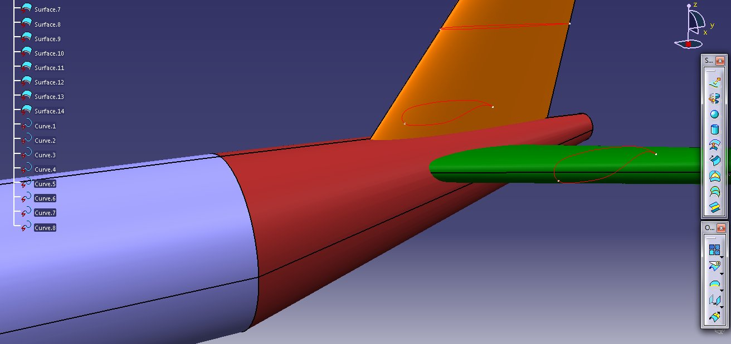

Fig. 3. Boeing 747, conventional tail

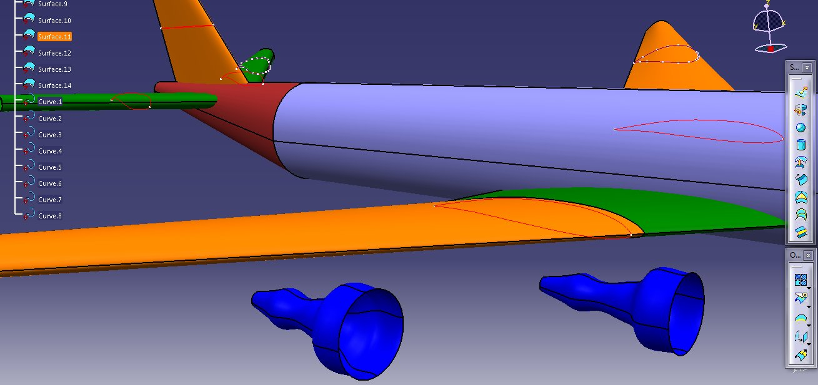

Fig. 4. Boeing 747, engines

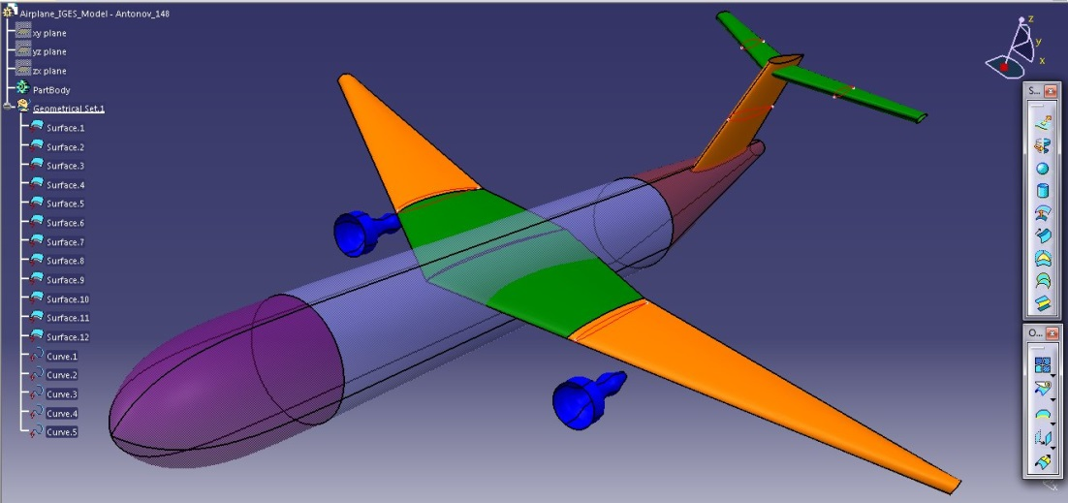

Fig. 5. Antonov 148

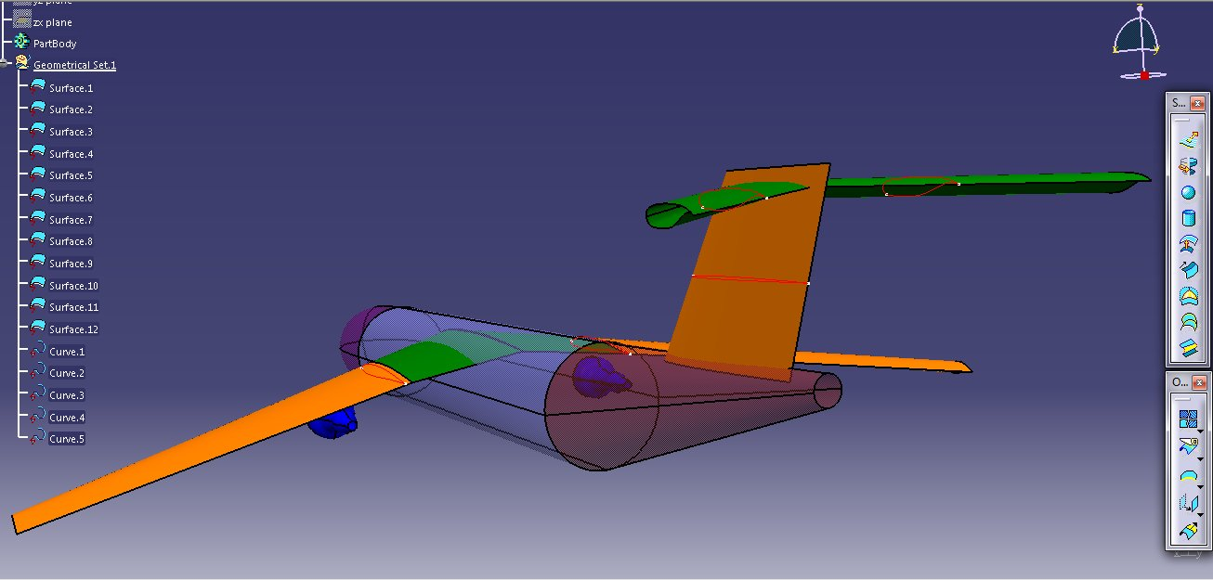

Fig. 6. Antonov 148, rear view, T-tail

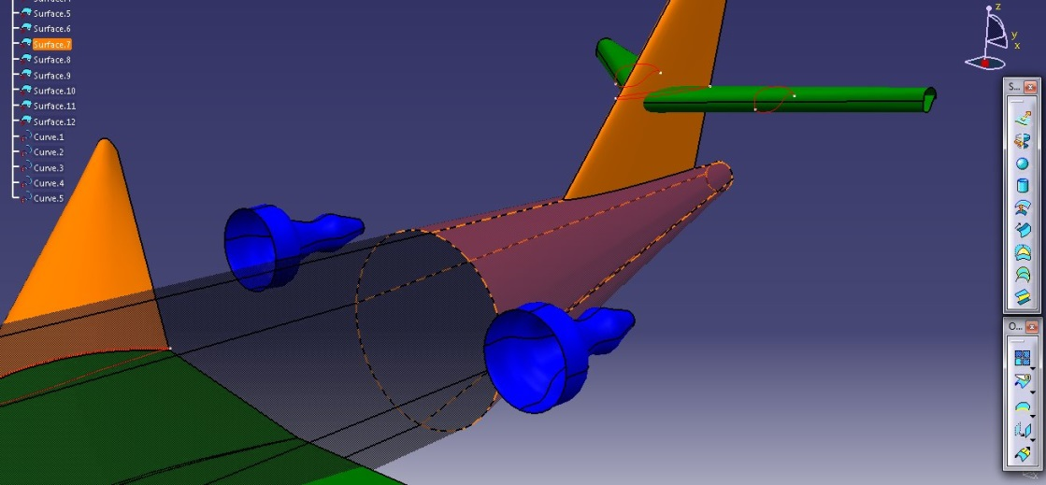

Fig. 7. Cessna Citation – tail part

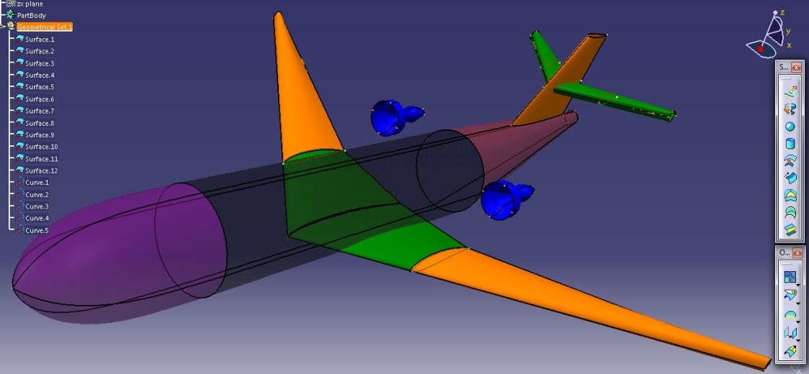

Fig.8. Cessna Citation – trimetric

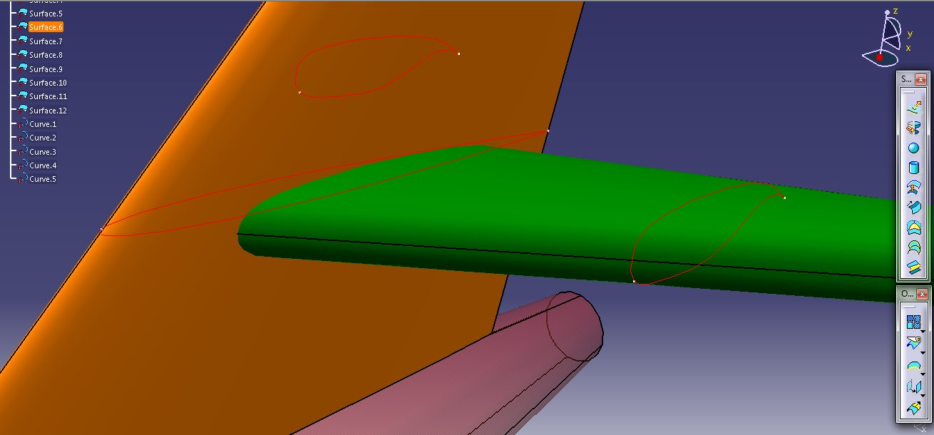

Fig.9. Cessna Citation – tail detail - MACs